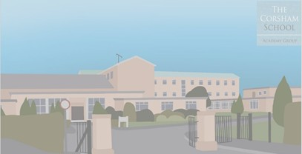


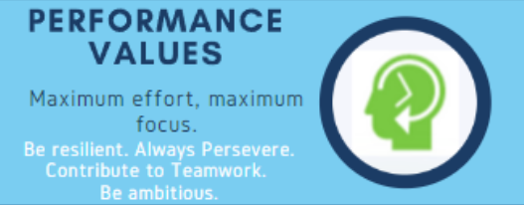
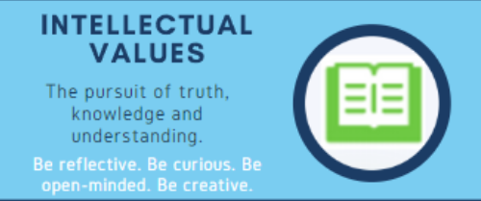

How we revise at The Corsham School
Contents
- Constant revision
- Resources to use
- Look – Cover – Write - Check
- Knowledge Mind-maps
- Making flashcards
- Create 10 knowledge questions
- Using Past Papers to master exam technique

Lessons at The Corsham School have a regular focus on knowledge retrieval (this means you can remember more). You will have completed knowledge retrieval in many forms including:
Constant Revision
- Retrieval questions in your Do Now Activities
- Mini quizzes
- Using mini white boards to help you retrieve your knowledge.
- Think – Pair – Share

Knowledge retrieval is really important to help you best prepare for your assessments (both throughout the year and in particular your end of year assessment). Knowing information is the key to success in your assessments. Our knowledge retrieval activities challenge you to find your knowledge from previous lessons, months and terms and therefore help you have the core knowledge you need to succeed. It is crucial that you consistently give your best effort in these activities to maximise your knowledge.

Homework activities also help you prepare for your assessments. Homework tasks include mini revision activities. By completing your homework tasks you are both practising revision activities and also improving your knowledge recall. The more knowledge you have and the more you practice retrieving that knowledge, the better placed you are to succeed in assessments.

Knowledge Organisers are full of the core knowledge you need to succeed in your subjects. The more you read, interact and use your knowledge organisers the more likely you are to learn the necessary knowledge you need. Therefore, you should keep all your knowledge organsiers safe to use when you revise independently. Your knowledge Organisers are just one resource that you can use to help you learn the knowledge you need for your exams.

Resources to use for revision.
There are many resources you can use to help you with your revision and knowledge retrieval (including your knowledge Organisers).
Have a look at your specific subject revision booklet for ideas and links to revision resources.

- Your Knowledge organiser.
- Your exercise books.
- Subject specific revision guides (if GCSE/Exam make sure it is the correct specification).
- Subject specific textbooks/workbooks (ask your teacher for advice on the best ones).
- Online platforms (BBC Bitesize/Seneca Learning/Kerboodle (if subscribed)).
- Past papers from GCSE/Alevel exam board websites.

Look – Cover – Write – Check - Repeat
What resources can be used for this activity?
- Core Knowledge from Knowledge Organsiers.
- Core knowledge from revision guides.
- Model answers from revision guides.
- Key terms and definitions.

How do I do this revision activity?
- Look at/read a piece of text or knowledge.
- Cover it up and try to write out the text/knowledge from memory.
- Check your answer to see how accurately you had remembered your piece of text/knowledge.
- Do it again (even if you got it right first time). By repeating the activity you are helping to get that knowledge into your long term memory.

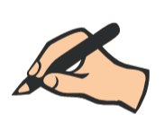
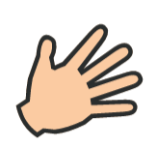



What does this look like?
Scan this QR code or click on the link to see it in practice.

https://youtu.be/QAuKIIbTJEw

https://youtube.com/shorts/BVwvYNP-KVQ?feature=share

Knowledge Mindmaps.
What resources can be used for this activity?
You need a selection of knowledge that can be grouped into separate categories.
- A whole section of a knowledge organiser page
- A chapter/page from a revision guide.
- Your exercise book that covers a variety of topics.
How do I do this revision activity?
- Choose your topic to revise
- Before you start – break your topic down into 4/5 sub topics (these are going to be your “arms” of the knowledge mindmap.
- Complete 1 “arm” at a time, dividing your arm into sub sections.
- Add pictures/sketches and diagrams to help you.


What does this look like?
Scan these QR codes to see it in practice or click on the link:
https://youtu.be/BahSSb2osCA
https://youtu.be/rEE_p7151Mk
Have a look at the examples below.
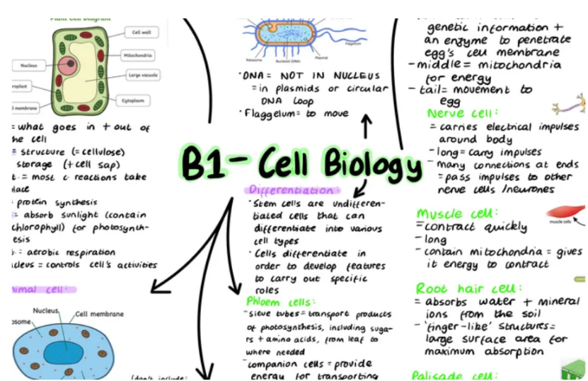
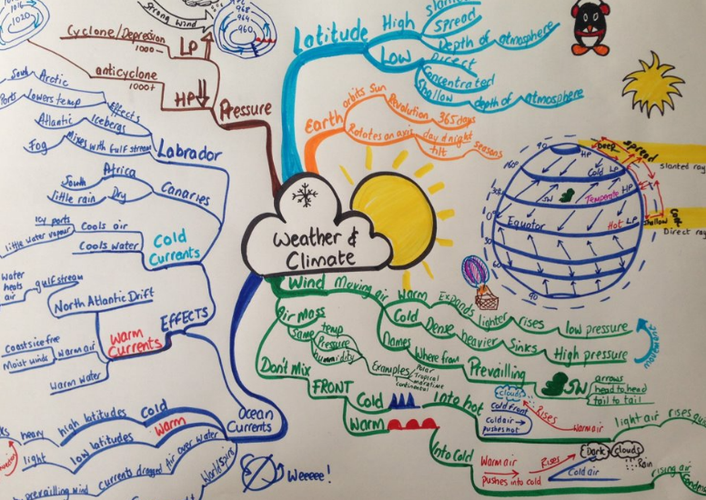

Knowledge Flash Cards
What resources can be used for this activity?
- Knowledge Organsiers
- Revision Guides
- Exercise books
- Suitable websites that your teacher has shown you.

How do I do this revision activity?
- The purpose is to reduce information into note forms on flash cards.
- Make sure you have 1 topic per flashcard.
- Give your flashcard a clear title and use bullet points to summarise your knowledge.
- Add in colour and pictures to help it stand out.
- Use your flashcards to complete a “Look-Cover-Write-Check-Repeat”.

What does this look like:


Scan these QR codes to see it in practice or click on the link:
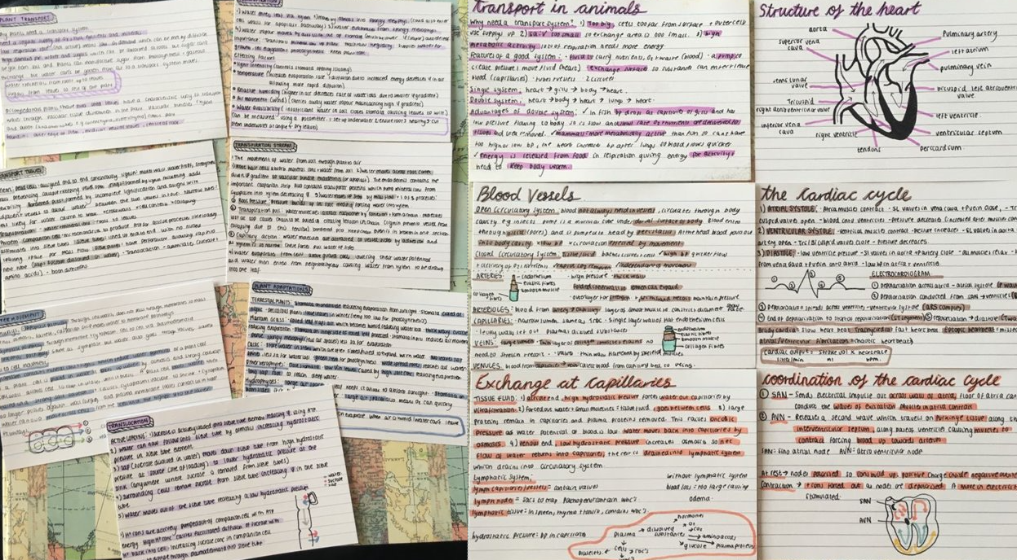
https://youtu.be/6oepNMh7MjM
https://youtube.com/shorts/PcHU3S9T9-A?feature=share

Have a look at the examples below.

What resources can be used for this activity?
Create 10 Knowledge Questions.
- Knowledge Organsiers
- Revision Guides
- Exercise books
- Suitable websites that your teacher has shown you.

How do I do this revision activity?
- Use your resource to find a key word or a piece of knowledge or a date.
- Devise and write out a question that only requires a short answer based on that knowledge. e.g.
  - “Finish the quotation from A Christmas Carol :‘Scrooge was as solitary as an ……..”
  - In Chemistry, what method is used to separate salt and water?
- Write out the answers in a different colour or on the back of your paper.
- Test another person with your questions.


What does this look like:
Scan these QR codes to see it in practice or click on the link:
https://youtu.be/gao71lXU7Xk

Use past papers to master exam technique.
What resources can be used for this activity?
- Past papers from the exam board website or from your teacher.
- A timer (really important).
- Optional – the mark scheme (from the website)/textbook/Knowledge Organiser.

How do I do this revision activity?
- Choose an exam question to complete.
- BUG your question (see below). This will help you to answer the question correctly.
- Make sure you know how long your chosen question should take you in an exam situation (this is often one minute per mark e.g. 6 mark question = 6 minutes).
- Answer the question in one colour using the exam technique that your teacher has taught you. Without any other resources (just your own knowledge). Try and keep to the time limit.
- When completed, use a different colour to add any knowledge or exam technique that you missed (this is where you can use the mark scheme from the website or a text book/knowledge organiser).

